\***GOOGLE DIALOG FLOW CHATBOT ASSIGNMENTS**\*

* **Prerequisite:** A Google account is required for connecting to Google Dialog flow. Create our Dialog flow account by using the link (https://dialogflow.com/). Click on Sign for Free and proceed with account creation.

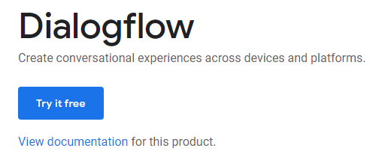

* Click on Sign-in with Google.

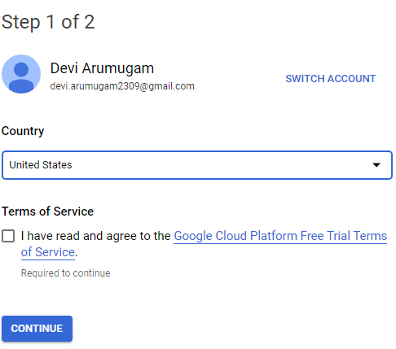

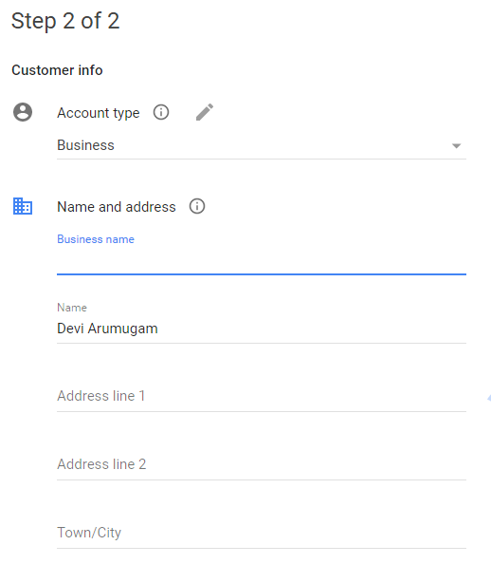

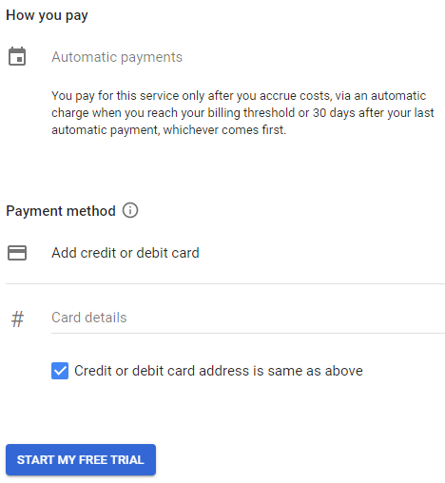

* Select your google account, and it will direct to the Google Dialog flow home page. Click on Go to console in the upper right corner to navigate to the home page of Google Dialog flow.

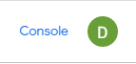

* Log in to Dialog flow. Click on Create Agent from the left menu.

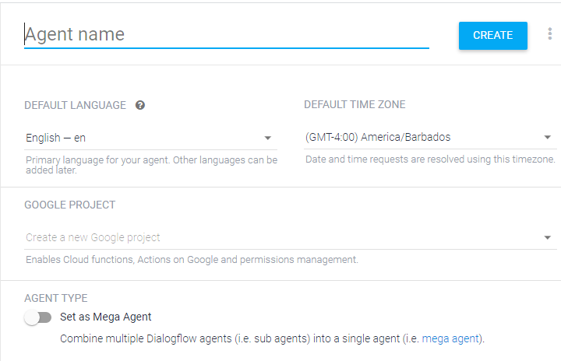

* Provide the name of the agent and click on the SAVE button to create the Agent.

* The Agent gets created and gets listed below the Dialog flow icon. If there are multiple agents, use the dropdown down button to select the Agent for editing or adding new data

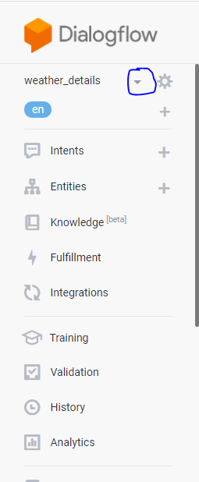

* Edit the Agent details using the setting icon.

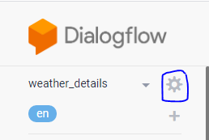

* Click on the plus icon as specified in the below image to create a new intent, which allows you to map what our user says to what our agent responds. Provide a name as Weather and click on the SAVE button.

* Click on ADD TRAINING PHRASE and then add Training phrases. Training phrases are examples of what users can say to match a particular intent. Adding numerous phrases with different variations and parameters will improve the accuracy of intent matching.

* Select the system entity @sys.geocity for the city. This step involves identifying the purpose of the user conversation and saving the data to improve communications.

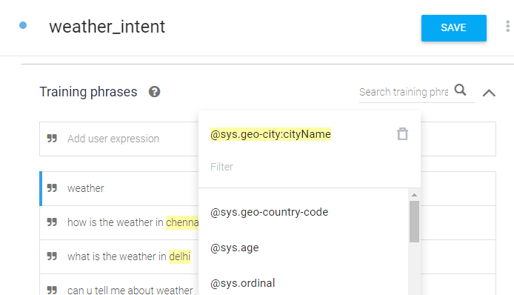

* I have created three intents.

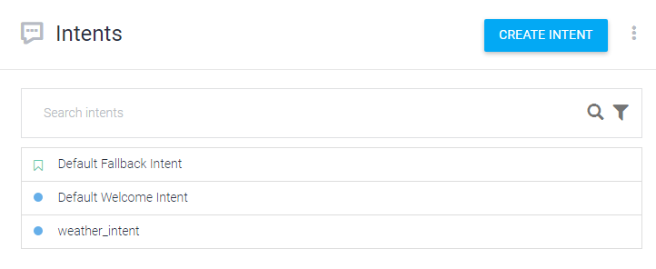

* Click on ADD RESPONSE to provide an appropriate response to user queries. Add the responses.

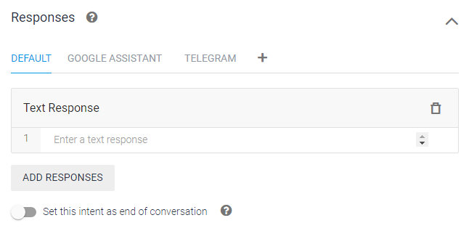

* Click on the SAVE button which is available in the upper right corner to save all the details of the intent Weather.

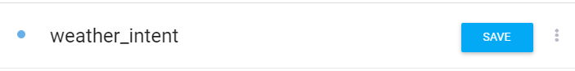

* We can use the test console to test our requests and check the responses from Agent.

* Before fulfillment, Testing is done once again.

* Fulfillment helps to use the information extracted by Dialog flow’s natural language processing to generate responses dynamically or to trigger actions in the backend. Enable fulfillment by sliding Enable webhook call for this intent to the intents, which involve some logic building or to trigger actions.

* Using Ngrok, I deployed the code.

* To enable the webhook call, go to fulfillment enable webhook.

* For above steps, we must Create python file. So, create a python file and then copy the below code and save it as app.py.

* Tested locally, working fine. Now I like to deploy in Heroku.
* Heroku Login and deployment steps are shown below.

* Deployment done successfully.
* Its time for integration.

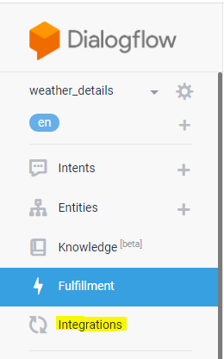

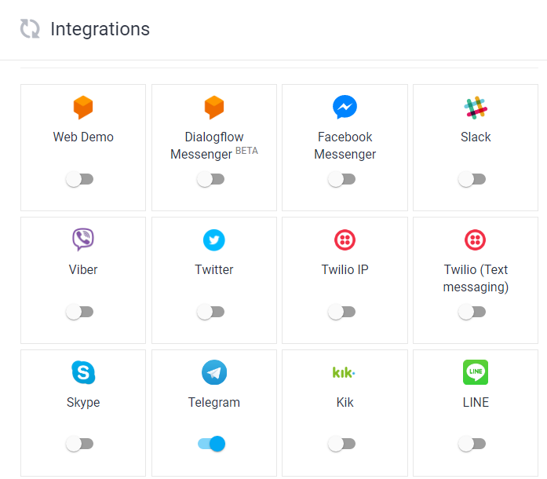

* I like to integrate with telegram app. So, I enable the link.
* To set up the Telegram integration for our agent, you'll need a Telegram account.
* Log-in to Telegram using the link https://telegram.me/botfather
* Click the Start button in the web interface or type /start in Telegram 3.
* Type /newbot and provide a name
* Provide a username for the bot, ending in "bot". Copy the generated access token.
* When you click the telegram link in dialog flow integration section, it will navigate to below page. Enter the telegram token we got it from telegram app.

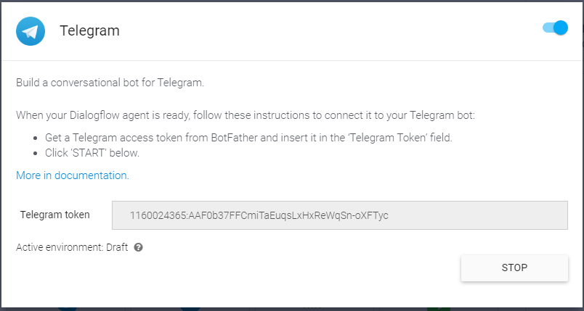

* Start talk with your bot.

* From all the above steps, I successfully created my chatbot in Dialog flow and deployed in Heroku. Finally, integrated with telegram app.